EXERCISE-28

28.Design DFA using simulator to accept the string the end with ab over set {a,b)

W= abbaabab

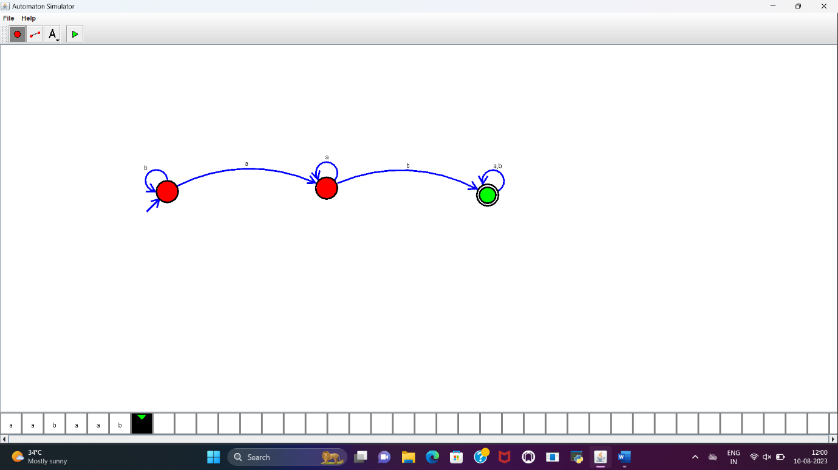

RESULT:

DFA to accept the string that end with ab over set {a,b} is designed and implemented successfully.